Procedure :

**Create Node Red service**

|  |  |
| --- | --- |
| Team Id | PNT2022TMID00945 |
| Project Name | GAS LEAKAGE MONITORING AND ALERTING SYSTEM |

Step 1: Login into IBM CLOUD account

Step2: In catalog, search for node red application

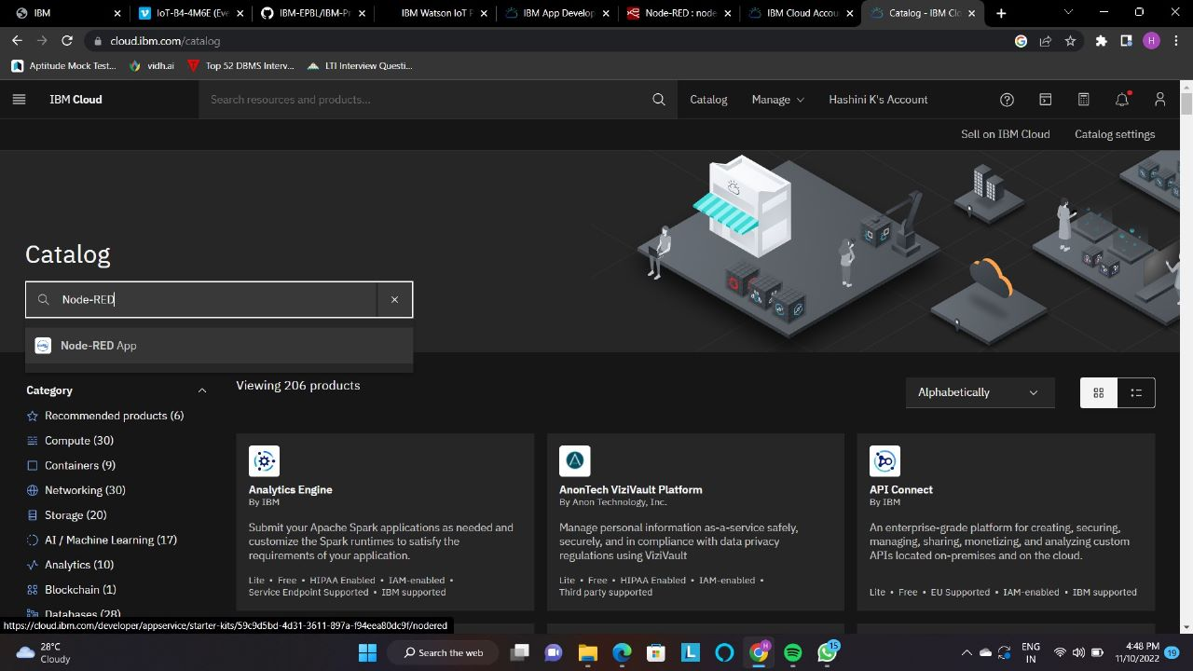

Step 3: Enter the project details and click on create Step 4: click on deploy option and deploy

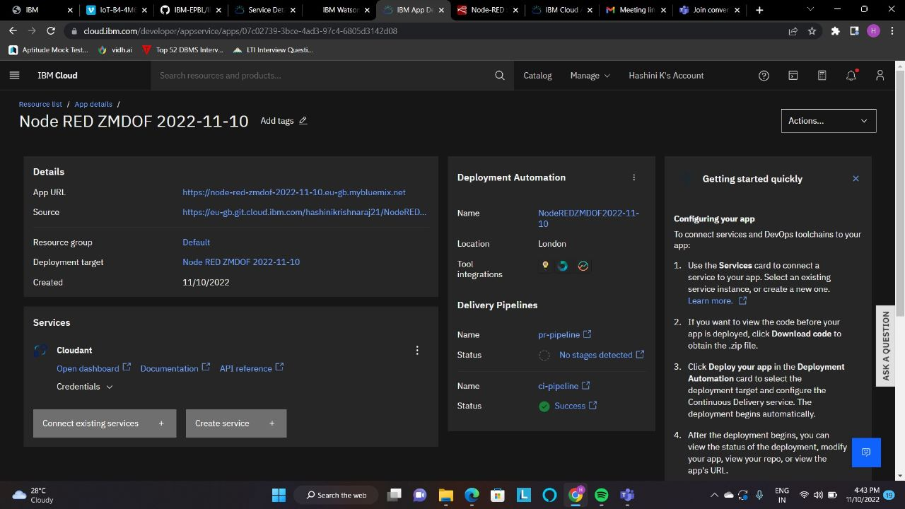

Step 5: Set up the environment for deploying and click on create.

Step 6: Now drag and drop the nodes and connect nodes.

